## **REACTJS-HOL**

## **Objectives**

* List the features of ES6
* Explain JavaScript let
* Identify the differences between var and let
* Explain JavaScript const
* Explain ES6 class fundamentals
* Explain ES6 class inheritance
* Define ES6 arrow functions
* Identify set(), map()

In this hands-on lab, you will learn how to:

* Use map() method of ES6
* Apply arrow functions of ES6
* Implement Destructuring features of ES6

**App.js:**

import React from 'react';

import ListofPlayers from './ListofPlayers';

import IndianPlayers from './IndianPlayers';

function App() {

  const flag = false;

  return (

    <div className="App">

      <h1>🏏 Cricket App</h1>

      {flag ? <ListofPlayers /> : <IndianPlayers />}

    </div>

  );

}

export default App;

**ListofPlayers.js:**

import React from 'react';

const ListofPlayers = () => {

  const players = [

    { name: "Virat Kohli", score: 85 },

    { name: "Rohit Sharma", score: 45 },

    { name: "KL Rahul", score: 60 },

    { name: "Shubman Gill", score: 75 },

    { name: "Hardik Pandya", score: 35 },

    { name: "Ravindra Jadeja", score: 90 },

    { name: "Rishabh Pant", score: 50 },

    { name: "Jasprit Bumrah", score: 20 },

    { name: "Yuzvendra Chahal", score: 95 },

    { name: "Mohammed Shami", score: 66 },

    { name: "Suryakumar Yadav", score: 72 }

  ];

  const filteredPlayers = players.filter(player => player.score < 70);

  return (

    <div>

      <h2>All Players</h2>

      <ul>

        {players.map((player, index) => (

          <li key={index}>{player.name} - {player.score}</li>

        ))}

      </ul>

      <h3>Players with score below 70</h3>

      <ul>

        {filteredPlayers.map((player, index) => (

          <li key={index}>{player.name} - {player.score}</li>

        ))}

      </ul>

    </div>

  );

};

export default ListofPlayers;

**IndianPlayers.js:**

import React from 'react';

const IndianPlayers = () => {

  const T20players = ["Virat", "Rohit", "Rahul", "Surya"];

  const RanjiPlayers = ["Pujara", "Rahane", "Shreyas", "Vihari"];

  const allPlayers = [...T20players, ...RanjiPlayers];

  const evenTeam = allPlayers.filter((_, index) => index % 2 === 0);

  const oddTeam = allPlayers.filter((_, index) => index % 2 !== 0);

  return (

    <div>

      <h2>All Indian Players</h2>

      <ul>

        {allPlayers.map((player, index) => (

          <li key={index}>{player}</li>

        ))}

      </ul>

      <h3>Even Team Players</h3>

      <ul>

        {evenTeam.map((player, index) => (

          <li key={index}>{player}</li>

        ))}

      </ul>

      <h3>Odd Team Players</h3>

      <ul>

        {oddTeam.map((player, index) => (

          <li key={index}>{player}</li>

        ))}

      </ul>

    </div>

  );

};

export default IndianPlayers;

**RESULT:**

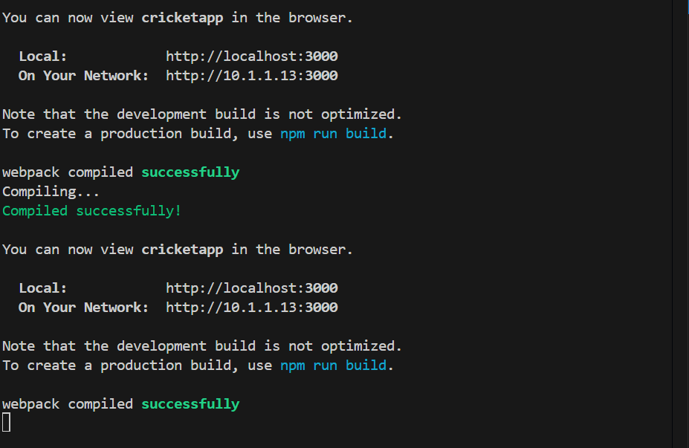

When Flag=true

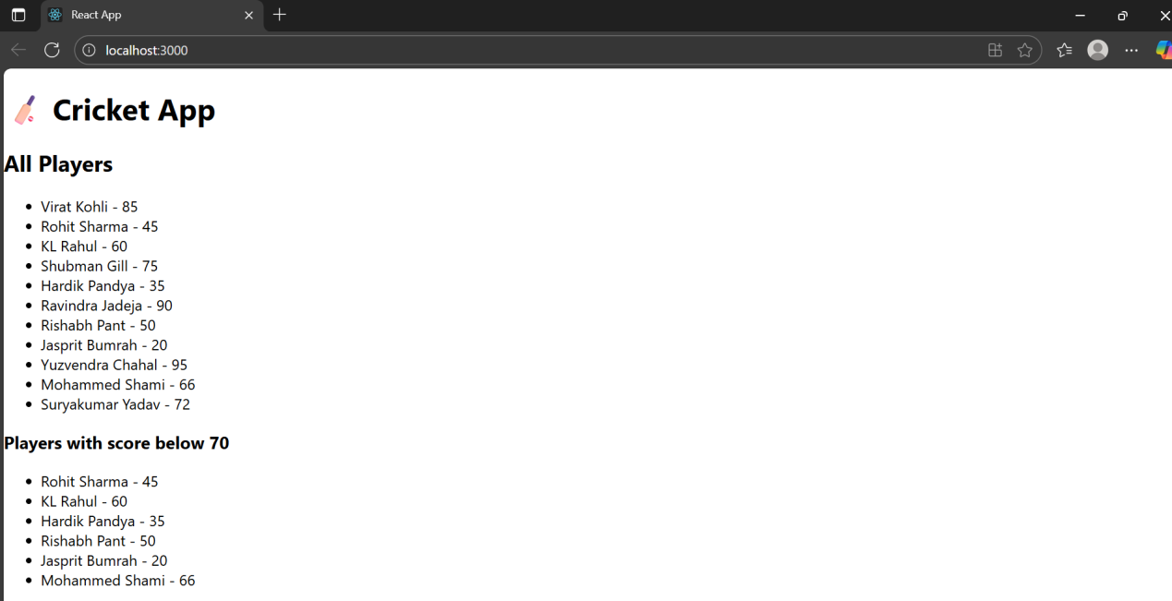

When Flag=false

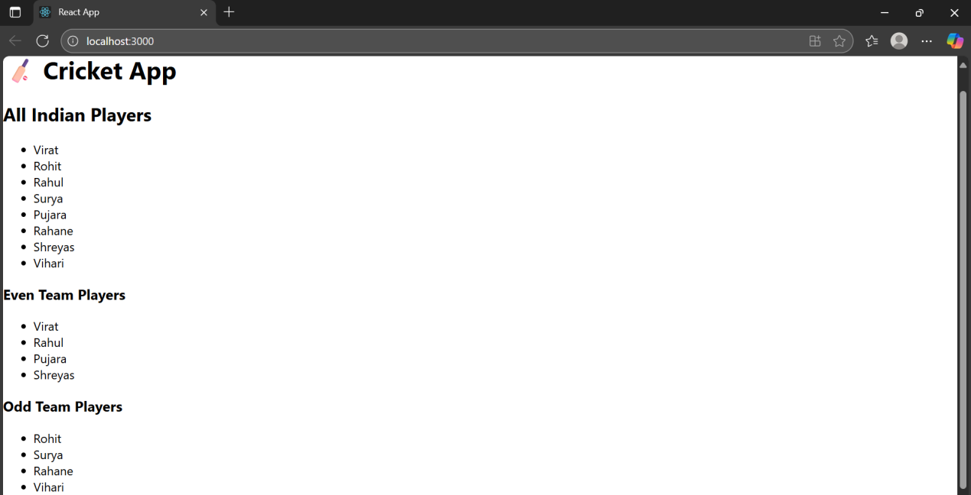

1. **REACTJS-HOL**

## **Objectives**

* Define JSX
* Explain about ECMA Script
* Explain React.createElement()
* Explain how to create React nodes with JSX
* Define how to render JSX to DOM
* Explain how to use JavaScript expressions in JSX
* Explain how to use inline CSS in JSX

In this hands-on lab, you will learn how to:

* Use JSX syntax in React applications
* Use inline CSS in JSX

**index.js:**

import React from 'react';

import ReactDOM from 'react-dom/client';

import App from './App';

const root = ReactDOM.createRoot(document.getElementById('root'));

root.render(<App />);

**App.js:**

import React from 'react';

import OfficeList from './components/OfficeList';

function App() {

  return (

    <div>

      <h1>Office Space Rental Application</h1>

      <OfficeList />

    </div>

  );

}

export default App;

**OfficeList.js:**

import React from 'react';

import imag1 from '../assets/imag1.jpg';

import imag2 from '../assets/imag2.jpg';

const OfficeList = () => {

  const offices = [

    {

      id: 1,

      name: 'Tech Park',

      rent: 55000,

      address: '123 Main St, Hyderabad',

      image: imag1,

    },

    {

      id: 2,

      name: 'Business Bay',

      rent: 65000,

      address: '456 Maple Ave, Bengaluru',

      image: imag2,

    },

  ];

  return (

    <div>

      {offices.map((office) => (

        <div key={office.id} style={{ border: '1px solid #ccc', padding: '10px', marginBottom: '10px' }}>

          <h2>{office.name}</h2>

          <img src={office.image} alt={office.name} width="200" />

          <p><strong>Address:</strong> {office.address}</p>

          <p style={{ color: office.rent < 60000 ? 'red' : 'green' }}>

            <strong>Rent:</strong> ₹{office.rent}

          </p>

        </div>

      ))}

    </div>

  );

};

export default OfficeList;

**RESULT:**

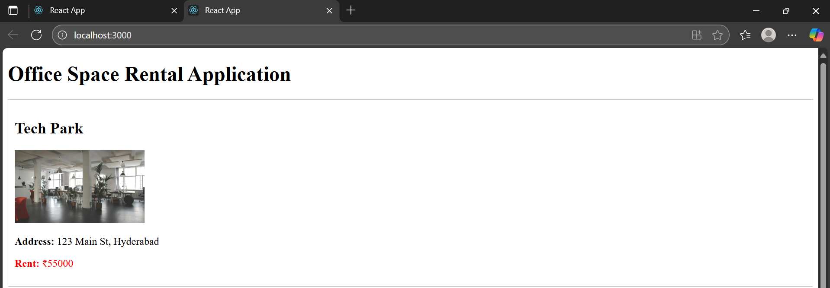

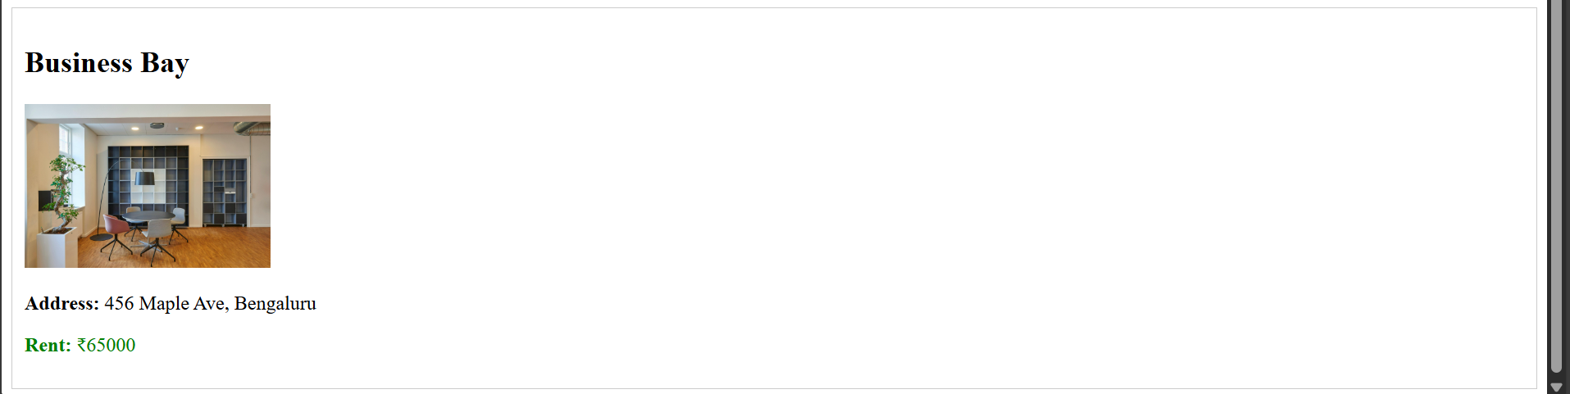

1. **REACTJS-HOL**

## **Objectives**

* Explain React events
* Explain about event handlers
* Define Synthetic event
* Identify React event naming convention

In this hands-on lab, you will learn how to:

* Implement Event handling concept in React applications
* Use this keyword
* Use synthetic event

**index.js:**

import React from 'react';

import ReactDOM from 'react-dom/client';

import App from './App';

const root = ReactDOM.createRoot(document.getElementById('root'));

root.render(<App />);

**App.js:**

import React from 'react';

import Counter from './components/Counter';

import Welcome from './components/WelcomeButton';

import ClickButton from './components/ClickButton';

import CurrencyConverter from './components/CurrencyConverter';

function App() {

  return (

    <div style={{ marginLeft: '20px' }}>

      <Counter />

      <Welcome />

      <ClickButton />

      <CurrencyConverter />

    </div>

  );

}

export default App;

**Counter.js:**

import React, { useState } from 'react';

function Counter() {

  const [count, setCount] = useState(5);

  const handleIncrement = () => {

    setCount(count + 1);

    alert("Hello! This is a static message.");

  };

  const handleDecrement = () => {

    setCount(count - 1);

  };

  return (

    <div>

      <h3>{count}</h3>

      <button onClick={handleIncrement}>Increment</button>

      <br /><br />

      <button onClick={handleDecrement}>Decrement</button>

      <br /><br />

    </div>

  );

}

export default Counter;

**WelComeButton.js:**

import React from 'react';

function showWelcome(name) {

  alert(`Hello! ${name}`);

}

function WelcomeButton() {

  return (

    <div>

      <button onClick={() => showWelcome('Member1')}>Say welcome</button>

      <br /><br />

    </div>

  );

}

export default WelcomeButton;

**ClickButton.js:**

import React from 'react';

function ClickButton() {

  const handleClick = (e) => {

    alert("I was clicked");

  };

  return (

    <div>

      <button onClick={handleClick}>Click on me</button>

      <br /><br />

    </div>

  );

}

export default ClickButton;

**CurrencyConverter.js:**

import React, { useState } from 'react';

function CurrencyConverter() {

  const [amount, setAmount] = useState('');

  const [currency, setCurrency] = useState('');

  const handleSubmit = (e) => {

    e.preventDefault();

    const converted = (parseFloat(amount) / 90).toFixed(2);

    setCurrency(`€${converted}`);

  };

  return (

    <div>

      <h2 style={{ color: 'green' }}>Currency Convertor!!!</h2>

      <form onSubmit={handleSubmit}>

        <label>

          Amount: <input type="text" value={amount} onChange={(e) => setAmount(e.target.value)} />

        </label>

        <br /><br />

        <label>

          Currency: <input type="text" value={currency} readOnly />

        </label>

        <br /><br />

        <button type="submit">Submit</button>

      </form>

    </div>

  );

}

export default CurrencyConverter;

**RESULT:**

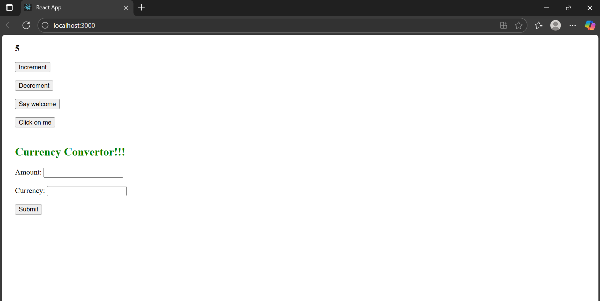

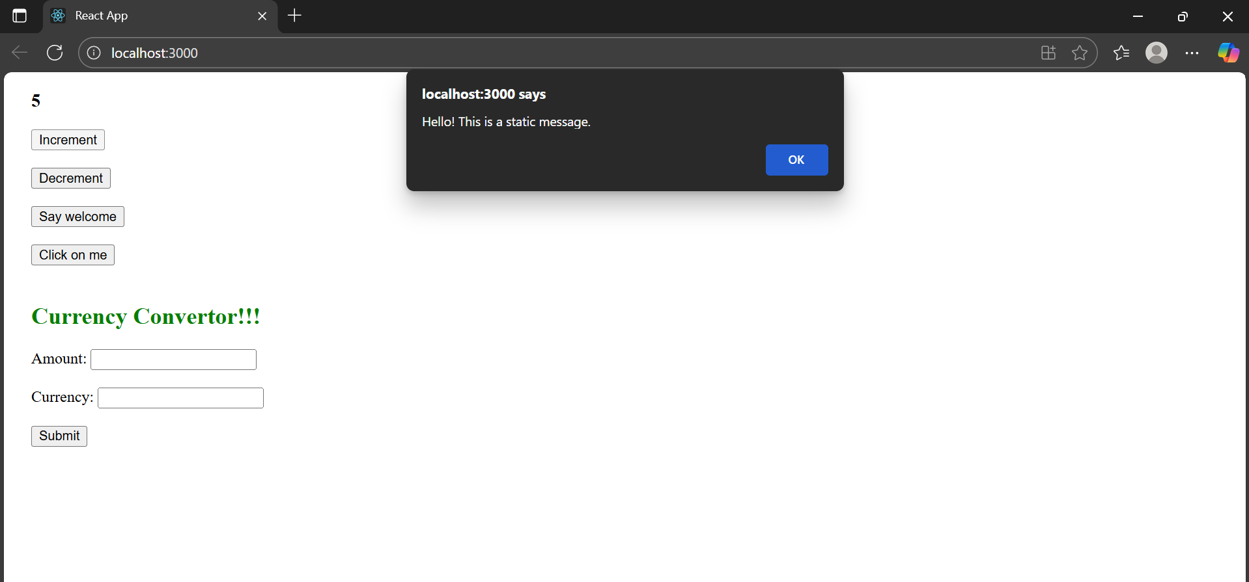

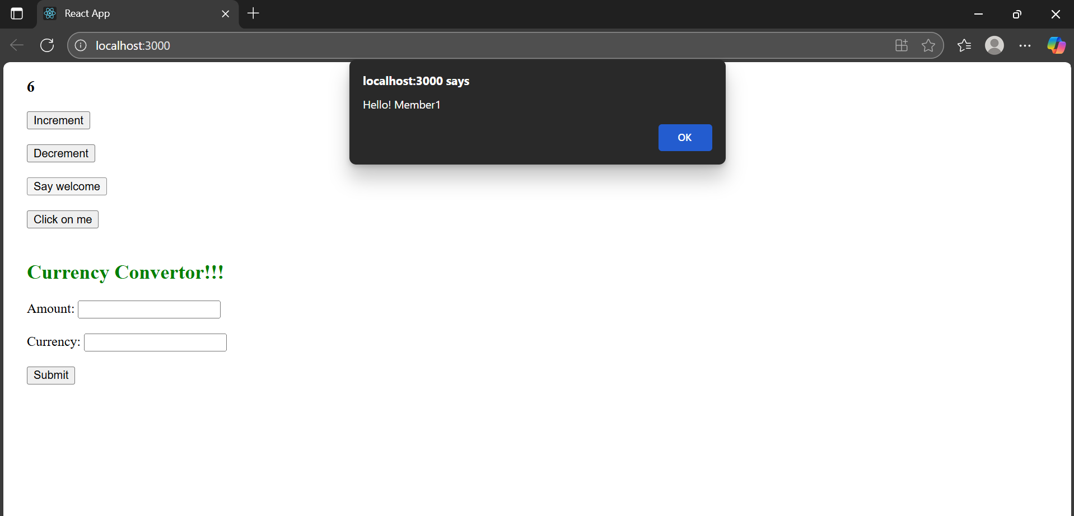

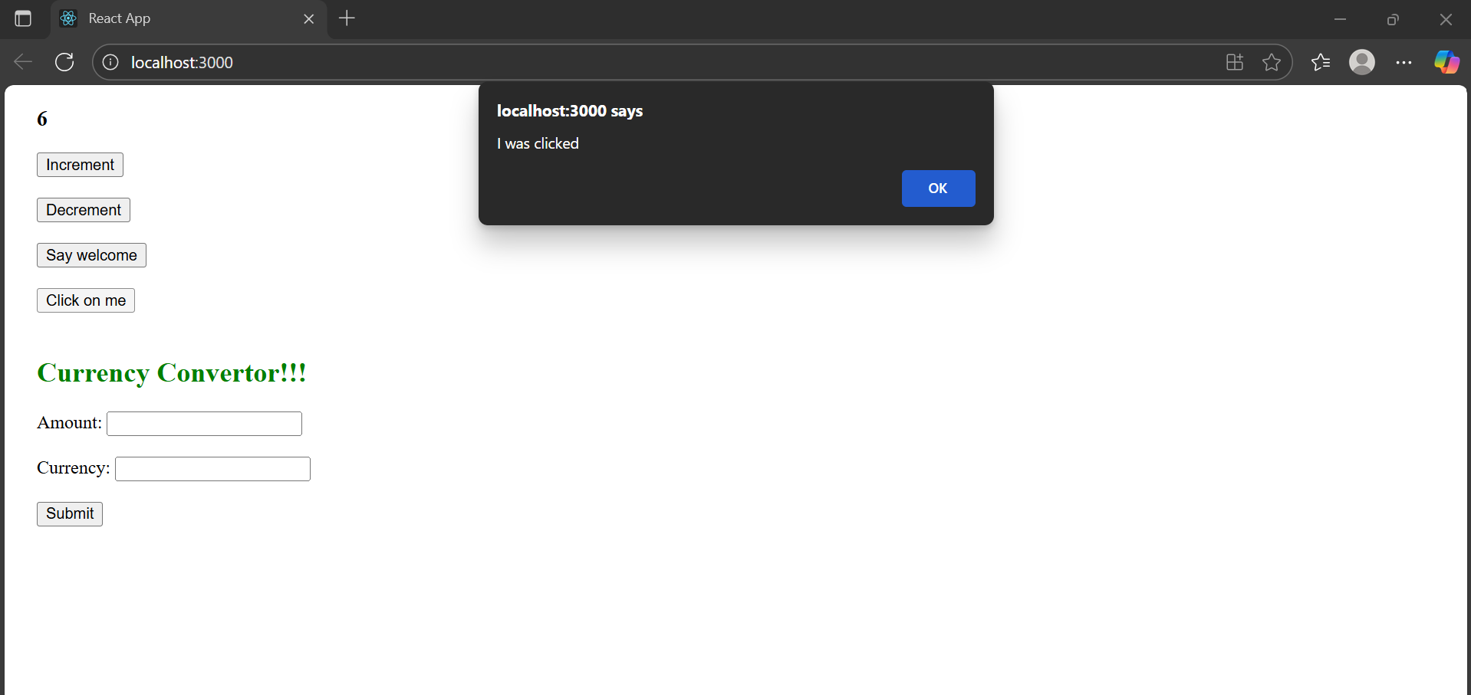

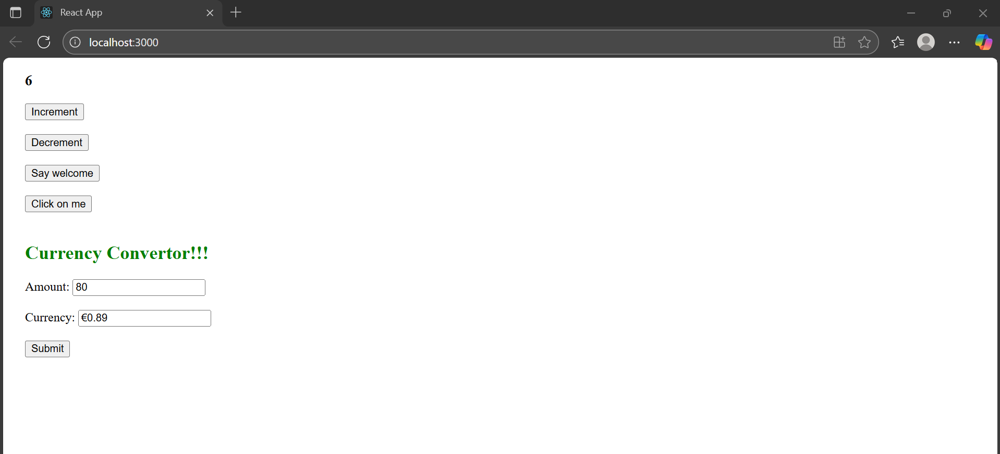

1. **REACTJS-HOL**

## **Objectives**

* Explain about conditional rendering in React
* Define element variables
* Explain how to prevent components from rendering

In this hands-on lab, you will learn how to:

* Implement conditional rendering in React applications

**index.js:**

import React from 'react';

import ReactDOM from 'react-dom/client';

import App from './App';

const root = ReactDOM.createRoot(document.getElementById('root'));

root.render(<App />);

**App.js:**

import React, { useState } from 'react';

import GuestPage from './components/GuestPage';

import UserPage from './components/UserPage';

function App() {

  const [isLoggedIn, setIsLoggedIn] = useState(false);

  const handleLogin = () => setIsLoggedIn(true);

  const handleLogout = () => setIsLoggedIn(false);

  return (

    <div style={{ padding: '20px' }}>

      <h1>✈️ Ticket Booking App</h1>

      <div style={{ marginBottom: '20px' }}>

        {isLoggedIn ? (

          <button onClick={handleLogout}>Logout</button>

        ) : (

          <button onClick={handleLogin}>Login</button>

        )}

      </div>

      {isLoggedIn ? <UserPage /> : <GuestPage />}

    </div>

  );

}

export default App;

**GuestPage.js:**

import React from 'react';

import FlightDetails from './FlightDetails';

const GuestPage = () => {

  return (

    <div>

      <h2>Welcome, Guest 👋</h2>

      <p>Please log in to book your tickets.</p>

      <FlightDetails />

    </div>

  );

};

export default GuestPage;

**UserPage.js:**

import React from 'react';

import FlightDetails from './FlightDetails';

const UserPage = () => {

  return (

    <div>

      <h2>Welcome, User ✅</h2>

      <FlightDetails />

      <button style={{ marginTop: '10px' }}>Book Ticket</button>

    </div>

  );

};

export default UserPage;

**FlightDetails.js:**

import React from 'react';

const FlightDetails = () => {

  return (

    <div>

      <h3>Available Flights:</h3>

      <ul>

        <li>Flight: AI-202 | From: Delhi | To: Mumbai | Time: 10:30 AM</li>

        <li>Flight: AI-305 | From: Chennai | To: Bangalore | Time: 1:00 PM</li>

        <li>Flight: AI-402 | From: Hyderabad | To: Kolkata | Time: 3:45 PM</li>

      </ul>

    </div>

  );

};

export default FlightDetails;

**RESULT:**

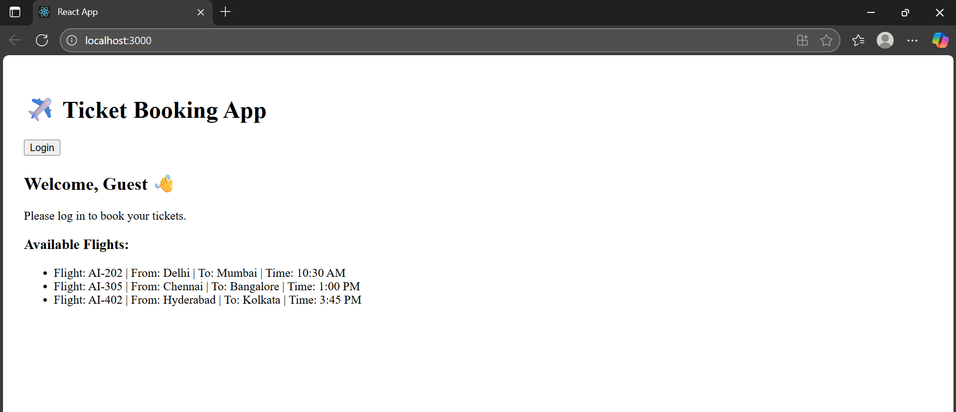

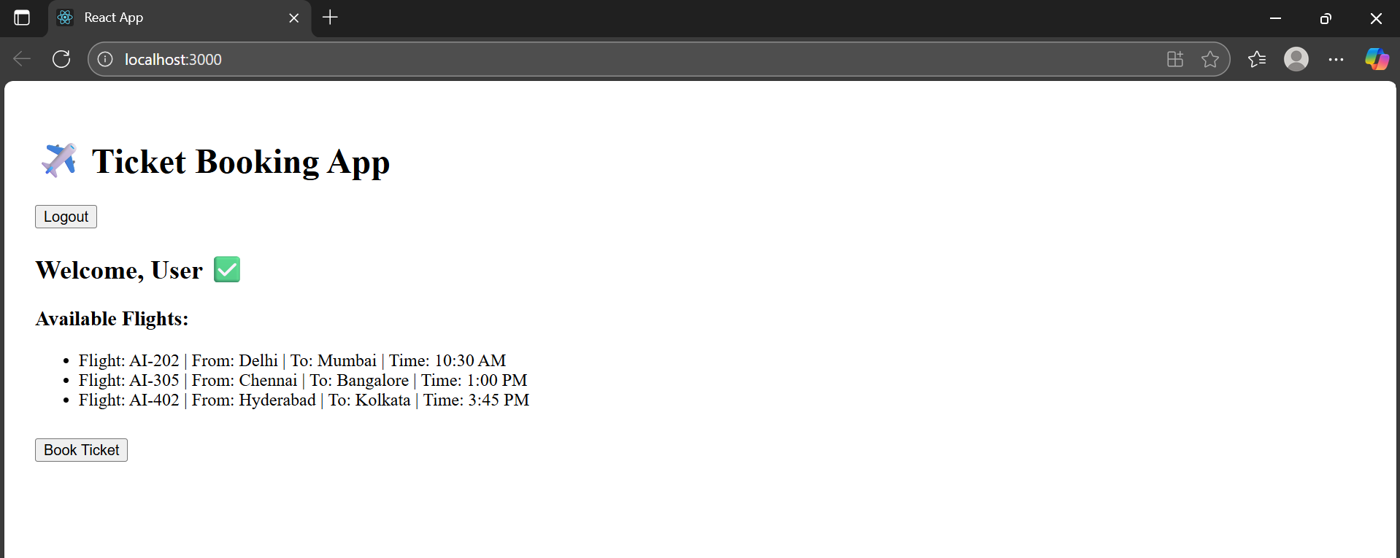

1. **REACTJS-HOL**

## **Objectives**

* Explain various ways of conditional rendering
* Explain how to render multiple components
* Define list component
* Explain about keys in React applications
* Explain how to extract components with keys
* Explain React Map, map() function

In this hands-on lab, you will learn how to:

* Implement conditional rendering in React applications

**index.js:**

import React from 'react';

import ReactDOM from 'react-dom/client';

import App from './App';

const root = ReactDOM.createRoot(document.getElementById('root'));

root.render(<App />);

**App.js:**

import React, { useState } from 'react';

import BookDetails from './components/BookDetails';

import BlogDetails from './components/BlogDetails';

import CourseDetails from './components/CourseDetails';

function App() {

  const [componentToShow, setComponentToShow] = useState('');

  const handleShow = (type) => {

    setComponentToShow(type);

  };

  let content;

  if (componentToShow === 'book') {

    content = <BookDetails />;

  } else if (componentToShow === 'blog') {

    content = <BlogDetails />;

  } else if (componentToShow === 'course') {

    content = <CourseDetails />;

  }

  return (

    <div style={{ padding: '20px' }}>

      <h1>Blogger App 📚</h1>

      <button onClick={() => handleShow('book')}>Show Book Details</button>

      <button onClick={() => handleShow('blog')} style={{ marginLeft: '10px' }}>Show Blog Details</button>

      <button onClick={() => handleShow('course')} style={{ marginLeft: '10px' }}>Show Course Details</button>

      <hr />

      {/* Element Variable Rendering */}

      {content}

      {/* Ternary Operator Rendering */}

      {componentToShow === '' && <p>Please select a component to display.</p>}

      {/* Logical AND Rendering */}

      {componentToShow === 'course' && <p style={{ color: 'green' }}>You're viewing Course Details</p>}

    </div>

  );

}

export default App;

**BookDetails.js:**

import React from 'react';

function BookDetails() {

  const books = [

    { id: 1, title: 'React for Beginners', author: 'John Doe' },

    { id: 2, title: 'Mastering React', author: 'Jane Smith' },

  ];

  return (

    <div>

      <h2>📖 Book Details</h2>

      <ul>

        {books.map((book) => (

          <li key={book.id}>{book.title} - {book.author}</li>

        ))}

      </ul>

    </div>

  );

}

export default BookDetails;

**BlogDetails.js:**

import React from 'react';

function BlogDetails() {

  const blogs = [

    { id: 1, title: 'Learning React', date: '2025-08-01' },

    { id: 2, title: 'Using Hooks Effectively', date: '2025-08-02' },

  ];

  return (

    <div>

      <h2>📝 Blog Details</h2>

      <ul>

        {blogs.map((blog) => (

          <li key={blog.id}>{blog.title} - {blog.date}</li>

        ))}

      </ul>

    </div>

  );

}

export default BlogDetails;

**CourseDetails.js:**

import React from 'react';

function CourseDetails() {

  const courses = [

    { id: 1, name: 'React Basics', duration: '4 weeks' },

    { id: 2, name: 'Advanced React', duration: '6 weeks' },

  ];

  return (

    <div>

      <h2>🎓 Course Details</h2>

      <ul>

        {courses.map((course) => (

          <li key={course.id}>{course.name} - {course.duration}</li>

        ))}

      </ul>

    </div>

  );

}

export default CourseDetails;

**RESULT:**

